Artificial intelligence

March of the machines

What history tells us about the future of artificial intelligence—and how society should respond
Jun 25th 2016 | From the print edition

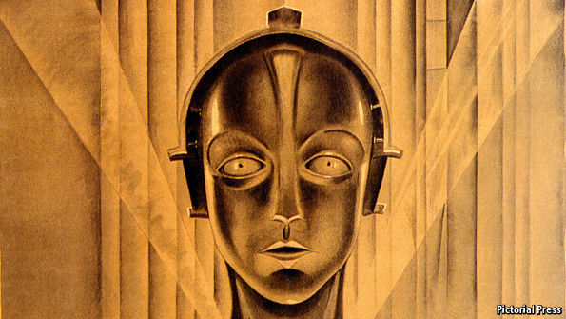
EXPERTS warn that “the substitution of machinery for human labour” may “render the population redundant”. They worry that “the discovery of this mighty power” has come “before we knew how to employ it rightly”. Such fears are expressed today by those who worry that advances in artificial intelligence (AI) could destroy millions of jobs and pose a “Terminator”-style threat to humanity. But these are in fact the words of commentators discussing mechanisation and steam power two centuries ago. Back then the controversy over the dangers posed by machines was known as the “machinery question”. Now a very similar debate is under way.
After many false dawns, AI has made extraordinary progress in the past few years, thanks to a versatile technique called “deep learning”. Given enough data, large (or “deep”) neural networks, modelled on the brain’s architecture, can be trained to do all kinds of things. They power Google’s search engine, Facebook’s automatic photo tagging, Apple’s voice assistant, Amazon’s shopping recommendations and Tesla’s self-driving cars. But this rapid progress has also led to concerns about safety and job losses. Stephen Hawking, Elon Musk and others wonder whether AI could get out of control, precipitating a sci-fi conflict between people and machines. Others worry that AI will cause widespread unemployment, by automating cognitive tasks that could previously be done only by people. After 200 years, the machinery question is back. It needs to be answered.
Machinery questions and answers
The most alarming scenario is of rogue AI turning evil, as seen in countless sci-fi films. It is the modern expression of an old fear, going back to “Frankenstein” (1818) and beyond. But although AI systems are impressive, they can perform only very specific tasks: a general AI capable of outwitting its human creators remains a distant and uncertain prospect. Worrying about it is like worrying about overpopulation on Mars before colonists have even set foot there, says Andrew Ng, an AI researcher. The more pressing aspect of the machinery question is what impact AI might have on people’s jobs and way of life.
This fear also has a long history. Panics about “technological unemployment” struck in the 1960s (when firms first installed computers and robots) and the 1980s (when PCs landed on desks). Each time, it seemed that widespread automation of skilled workers’ jobs was just around the corner.
Each time, in fact, technology ultimately created more jobs than it destroyed, as the automation of one chore increased demand for people to do the related tasks that were still beyond machines. Replacing some bank tellers with ATMs, for example, made it cheaper to open new branches, creating many more new jobs in sales and customer service. Similarly, e-commerce has increased overall employment in retailing. As with the introduction of computing into offices, AI will not so much replace workers directly as require them to gain new skills to complement it (see our special report in this issue). Although a much-cited paper suggests that up to 47% of American jobs face potential automation in the next decade or two, other studies estimate that less than 10% will actually go.
Even if job losses in the short term are likely to be more than offset by the creation of new jobs in the long term, the experience of the 19th century shows that the transition can be traumatic. Economic growth took off after centuries of stagnant living standards, but decades passed before this was fully reflected in higher wages. The rapid shift of growing populations from farms to urban factories contributed to unrest across Europe. Governments took a century to respond with new education and welfare systems.
This time the transition is likely to be faster, as technologies diffuse more quickly than they did 200 years ago. Income inequality is already growing, because high-skill workers benefit disproportionately when technology complements their jobs. This poses two challenges for employers and policymakers: how to help existing workers acquire new skills; and how to prepare future generations for a workplace stuffed full of AI.
An intelligent response
As technology changes the skills needed for each profession, workers will have to adjust. That will mean making education and training flexible enough to teach new skills quickly and efficiently. It will require a greater emphasis on lifelong learning and on-the-job training, and wider use of online learning and video-game-style simulation. AI may itself help, by personalising computer-based learning and by identifying workers’ skills gaps and opportunities for retraining.
Social and character skills will matter more, too. When jobs are perishable, technologies come and go and people’s working lives are longer, social skills are a foundation. They can give humans an edge, helping them do work that calls for empathy and human interaction—traits that are beyond machines.
And welfare systems will have to be updated, to smooth the transitions between jobs and to support workers while they pick up new skills. One scheme widely touted as a panacea is a “basic income”, paid to everybody regardless of their situation. But that would not make sense without strong evidence that this technological revolution, unlike previous ones, is eroding the demand for labour. Instead countries should learn from Denmark’s “flexicurity” system, which lets firms hire and fire easily, while supporting unemployed workers as they retrain and look for new jobs. Benefits, pensions and health care should follow individual workers, rather than being tied (as often today) to employers.
Despite the march of technology, there is little sign that industrial-era education and welfare systems are yet being modernised and made flexible. Policymakers need to get going now because, the longer they delay, the greater the burden on the welfare state. John Stuart Mill wrote in the 1840s that “there cannot be a more legitimate object of the legislator’s care” than looking after those whose livelihoods are disrupted by technology. That was true in the era of the steam engine, and it remains true in the era of artificial intelligence.

