Leland artist's work chosen for Sandwich Park District mascot
By KATRINA MILTONEmail
1:04 am
Katrina J.E. Milton - kmilton@shawmedia.com
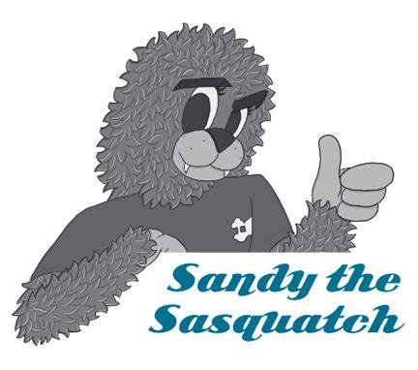
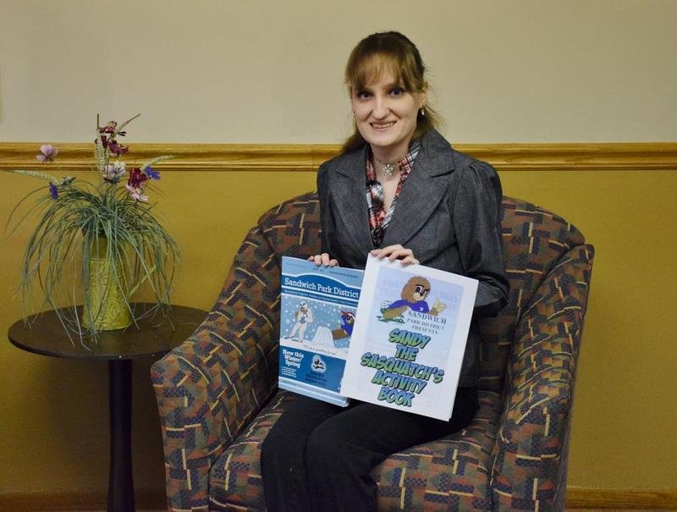
Katrina J.E. Milton - kmilton@shawmedia.com
SANDWICH – Bethany Gunderson of Leland remembers a time when she was afraid to show others her artwork because she worried about negative criticism.
Those days are long behind her because Gunderson has a certificate in graphic design and animation from Waubonsee Community College and is a freelance artist with her own business, Me on the Computer.
Gunderson’s artwork was chosen for the design of the Sandwich Park District’s new mascot, Sandy the Sasquatch.
Twenty-four-year-old Gunderson, who is autistic, said that drawing has been a fun way for her to be creative.
“I’ve been drawing for as long as I remember, and it’s grown into a passion,” she said. “It’s a really nice way I can express myself, my thoughts and my emotions. … At first, I was worried about other people’s reactions and feedback, but it’s helped me build up my confidence. I’ve had to work up the courage and face my insecurities.”
Gunderson’s mom, Stacy, said her daughter’s artwork has helped her communicate.
“Bethany was delayed in her speech development, and her drawings let us know what she was thinking,” Stacy Gunderson said. “She attended a special education school for junior high, and her teachers and speech therapist used her drawings to help her expand her vocabulary. So drawing has had a pretty significant impact on her in a lot of ways.”
Last spring, the Sandwich Park District was looking to invigorate their marketing strategy and branding by creating the mascot Sandy the Sasquatch.
Park district office manager Shawn Rickert attends the same church as the Gunderson family.
“Bethany used to draw me pictures as gifts,” Rickert said. “When we were looking for an artist, I just knew that Bethany would be a good fit.”
Rickert suggested the idea to Bethany Gunderson, and set up a meeting with Sandwich Park District Executive Director Michael McCann.
“We wanted an artist that could take a mythological creature and make it accessible and friendly,” McCann said. “We wanted our Sasquatch to be someone you wanted to hug and play baseball with.”
McCann and Rickert met with Gunderson to create the concept of the mascot, and with trial and error, the design was finalized in last fall.
The park district recently released an activity book of Gunderson’s artwork of Sandy the Sasquatch. The book features coloring pages, mazes, connect-the-dots and spot the difference puzzles. The activity book is free and can be picked up at the Sandwich Park District’s office, 1001 N. Latham St. in Sandwich.
Gunderson continues to meet with park district staff to discuss artwork designs every other month, and she is currently working on artwork for upcoming spring and summer brochures.
McCann also has plans for Gunderson to lead art classes at the park district through the Kishwaukee Special Recreation Association.
“I’m excited because this has helped launch my professional career as an artist,” Gunderson said. “It’s a really good opportunity for me, and I hope to continue working for the park district in the future. I’ve learned that suggestions can be made and that change is not a bad thing. I just hope others get inspired to learn new things. What’s life without a little risk? Put yourself out there and see what others have to say.”
To contact Bethany Gunderson about her artwork or her freelance business, email her at motc494@gmail.com.

