‘Am I reading this right?’ Beach weather on the way following L.A.’s snow day
By HANNAH FRY
FEB 22, 2019 | 12:10 PM
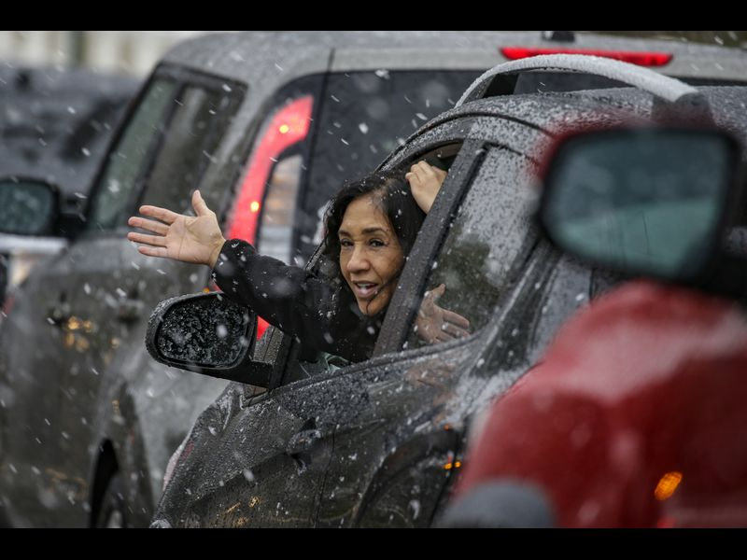
Liz Scales, 56, sticks her hand out to feel the falling snow in Rancho Cucamonga. (Irfan Khan / Los Angeles Times)

Less than a week after Los Angeles experienced its first snow day in years, Angelenos will be able to hang up their winter coats and pull out their swimsuits.
That’s right, sun-worshipers, beach weather is right around the corner.
The idea that temperatures hovering in the low 30s overnight in Los Angeles would make way for sunny skies and highs in the mid-70s by the end of next week surprised even forecasters on Friday.
“Am I reading this right?” Kristen Stewart, a meteorologist with the National Weather Service in Oxnard, said pausing as she checked the forecast. “OK, wow.”

The mercury will rise gradually over the next several days before reaching about 74 degrees with sunny skies by Thursday, Stewart said.
“We’re not going to be seeing any more storm systems next week, and temperatures will rebound back to normal,” she said. “I think we deserve it.”
Next week’s weather forecast is in stark contrast to the dusting of snow that transformed portions of Los Angeles County into a winter wonderland Thursday. Snowflakes fell in Thousand Oaks, Simi Valley, Calabasas, Northridge and Pasadena, all which sit at elevations between 700 and 1,000 feet.
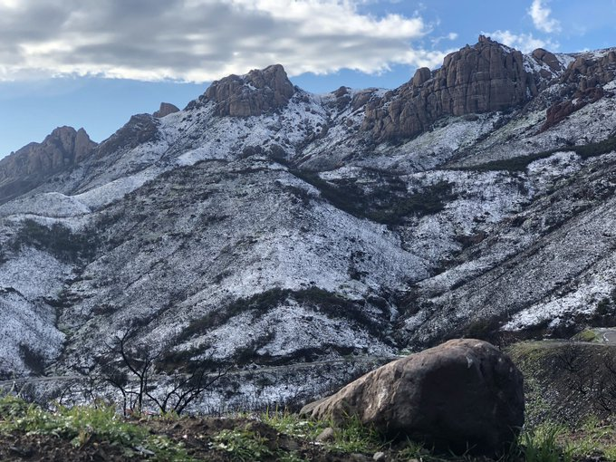
Even portions of West Hollywood, the Malibu Pier, Leo Carrillo Beach, Point Dume and Zuma Beach received a light dusting. In most areas, the snow melted not long after it hit the ground, but it still made for an enchanting sight for many Angelenos.
Many took to social media to express their delight and awe over the rare snowfall. Even Jerry O’Connell of “Stand By Me” piped in.
“Calabasas, Calif., where the Kardashians live,” he said in a video on Twitter, pointing at specks of snow on a car. “It’s snowing right now. Look at this. Snow. Snow. Not hail. Snow.”

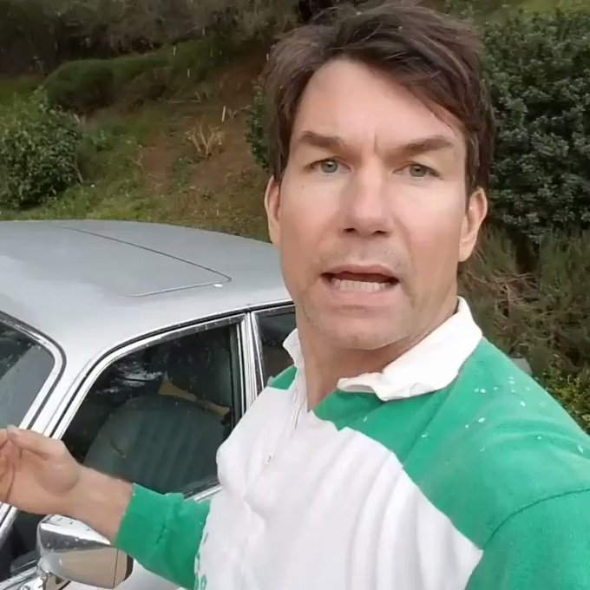

Of course, the unexpected snowstorm caused some travel delays in the Southland, temporarily closing several major roadways into the mountains and the 5 Freeway through the Grapevine. A portion of State Route 74 from San Juan Capistrano to Lake Elsinore remained closed overnight because of icy conditions but reopened mid-morning Friday, according to Caltrans.
Snow in lower elevations in Southern California is certainly rare, but it’s not the first time it’s happened.
The last significant and widespread measurable snow in the Los Angeles and Ventura county valleys was on Feb. 8, 1989, when up to 5 inches of snow fell in portions of the San Fernando Valley westward to Thousand Oaks and Simi Valley. Small amounts of snow also dusted portions of Los Angeles County in 2007, according to newspaper archives.
The last time downtown Los Angeles saw any snow was in 1962, when a trace was reported on two consecutive days in January. Measurable snow has fallen in downtown just twice since records began in 1877 — first in January 1932 when 2 inches of powder was recorded, and again in January 1949.
Here’s a brief history of that famous L.A. snowstorm from former Times history writer Cecilia Rasmussen:
“On Jan. 10, 1949, in the middle of the worst housing shortage in Los Angeles history, more than half an inch of snow covered the Civic Center. The San Fernando Valley was pelted with the unfamiliar white stuff for three days, accumulating almost a foot. The Rose Bowl was transformed into “a dishpan full of milk,” by one account. An Alhambra hardware store put up a sign that said, ‘Snow Plows for Rent — Hurry!’ A snowman appeared in Eagle Rock, wearing a sombrero, and the city of Reno, Nev., sent L.A. a snow shovel.”

