- Telegraph
News

Prince Harry and Meghan Markle's wedding date: Couple will marry on Saturday May 19
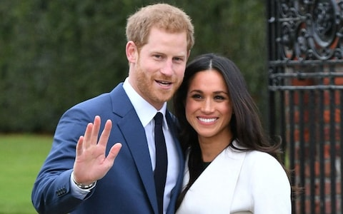
Prince Harry and Meghan Markle, pictured on the day of their engagement, will marry in St George's Chapel, Windsor Castle CREDIT: DOMINIC LIPINSKI /PA

By Danny Boyle
15 DECEMBER 2017 • 5:02PM
Prince Harry and Meghan Markle's wedding is to take place on Saturday May 19, Kensington Palace has announced.
The pair, whose engagement was confirmed last month, are tying the knot at St George's Chapel in Windsor Castle.
The couple's chosen day clashes with another big event - it is also the FA Cup final at Wembley.
As President of the Football Association, Harry's older brother the Duke of Cambridge usually attends the high-profile match and presents the trophy.
But this year, William, who is tipped to be Harry's best man, looks likely to be otherwise engaged with wedding duties.
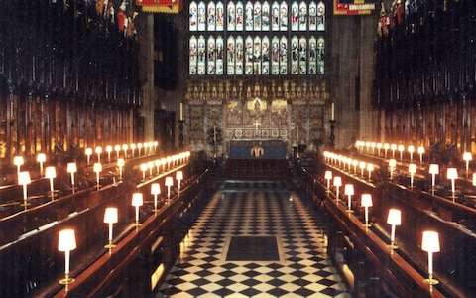
The interior of 15th Century St George's Chapel, Windsor Castle CREDIT: ROYAL COLLECTION
Harry and Ms Markle have gone against tradition by choosing a Saturday.
Royal weddings usually take place on a weekday. The Duke and Duchess of Cambridge wed on a Friday and the Queen on a Thursday.
But Harry and his fiancee's choice avoids the issue of whether or not the royal wedding should be a Bank Holiday.
The May wedding will also have been picked to give Kate time to recover after the birth of her third child, which is due in April.
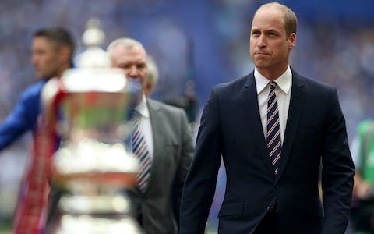
FA President Prince William, pictured at Wembley last year, usually presents the trophy CREDIT: NICK POTTS /PA
After the couple's engagement was announced last month, Ms Markle, the American actress, is set to appear at church with the Windsors at Sandringham on Christmas Day.
Palace aides have already said that the prince and Ms Markle's wedding will "reflect their characters and personalities" and be a moment of "fun and joy".
They will say "I do" in the historic surrounds of the Castle's 15th century St George's Chapel.
Ms Markle, who is to become a British citizen, is being both baptised and confirmed ahead of the religious ceremony.
The Royal family are paying for the wedding, including the church service, the music, the flowers and the reception.
But the security costs for the high-profile event are falling to the taxpayer.
The Queen will be there, as will the rest of the Royal family, along with Ms Markle's parents Thomas Markle and Doria Ragland.
Prince George and Princess Charlotte look set take on the roles of pageboy and bridesmaid.
Commenting on the fixture clash, an FA spokesman said: "Saturday 19 May promises to be a wonderful day with such a special royal occasion being followed by English football's showpiece event, the Emirates FA Cup Final.
"With millions coming together to watch both events at home and around the world, it will be a day to celebrate."
Harry proposed to Suits star Ms Markle during a cosy night in over a roast chicken dinner after a 16-month whirlwind romance.
In their engagement interview he told of how "the stars were aligned" when he fell for his future wife, whom he met on a blind date.

