News › London

Stressed-out, time-pressed Londoners waste more food than anybody else in the UK - and it's making them sad
- ELEANOR ROSE
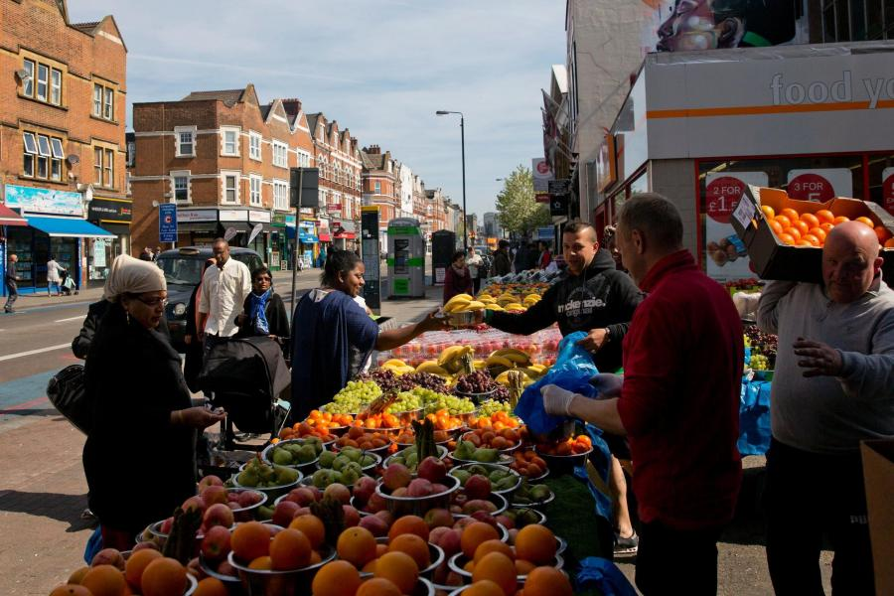Fresh hell: Londoners are chucking out more of their food than anybody else AFP/Getty Images
Guilt-ridden Londoners are wasting more food than anybody else in the country, a new survey has found.
28 per cent of the capital's residents chuck out at least a tenth of the fruit and veg they buy every week, compared with 22 per cent across the rest of the country.
It is stressing them out, according to the research, which found that 51 per cent of Londoners felt guilty throwing out food, while 32 per cent reported pangs of sadness as they lobbed their fresh veg in the bin.
37 per cent said their council provided no separate provision for the disposal of food waste, so it was disposed of with general waste.
Young people were the worst when it came to wasting food, according to the research.
Nationally, under-25s were most likely to bin fruit or veg, with 92 per cent of 18-24 year olds disposing of some every single week - 17 percentage points higher than the UK average of 75 per cent.
Over 65s were the least likely to chuck out food.
Food tech firm It's Fresh!, which commissioned the research from pollster Populus, is developer of a discreet sheet-like filter that keeps food fresh by absorbing ethylene, which is emitted by fruits and some veg as they begin to ripen.
It can extend the shelf life of fresh produce by up to four days.
Simon Lee, co-founder of It's Fresh!, said: “The research clearly shows people are deeply frustrated by the food they’re forced to throw away and that this waste is mainly down to food not being used in time.
“A lot of this waste is genuinely needless – fresh food can and should last longer and more needs to be done with technology to make this happen. Technology like ours has the potential to hugely reduce waste.
“Wasting food wastes everything and more needs to be done to help people reduce what they throw away.”
According to Recycle For London's Love Food Hate Waste campaign, throwing out fruit and veg costs the average person in London £200 a year, rising to £700 for a family with children.
Processing the waste us thought to cost authorities over £50million each year.

