The Venice BiennaleContemporary art gets a conscience
Why the most important event in the international art calender is being called the “hippy” Biennale
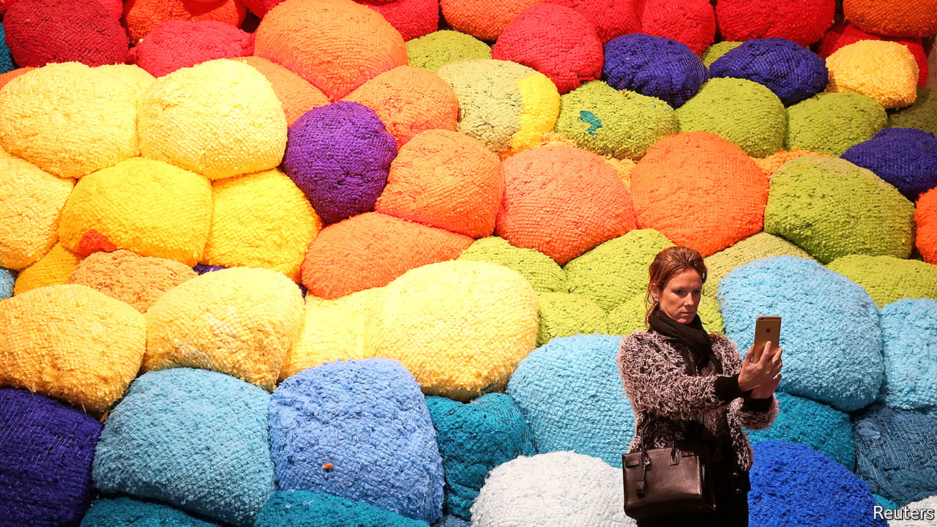

Print edition | Books and arts
May 20th 2017| VENICE

IN A disused medieval rope factory in Venice a canvas swag and reels of coloured thread hang from the ceiling. Various visitors, mostly women, perch on stools around it, stitching on items they have taken from their pockets and their handbags. Others wait to join in. This is a work of art by David Medalla, a 75-year-old artist from the Philippines. It is “participatory”, like many of the pieces around it. In art circles this means it is about the creativity of everyone rather than the genius of the individual; the use of domestic materials and techniques confers dignity on work that is mostly done by women and low-tech labour.
The Venice Biennale, which opened on May 13th, is the most important event in the international art calendar. It was founded in 1895, initially to champion living Italian artists, and, apart from interruptions during the first and second world wars, it has taken place ever since. The inauguration of the first national pavilion, Belgium’s, in 1907, turned the Biennale into the art equivalent of a world fair; 86 countries now have an official display.
Part of what gives the Venice Biennale its energy is that no single entity controls either the art or how it is funded. The city provides the showcase, the artists the show. National institutions, such as the British Council, do their bit. But more is needed. Although the Biennale’s own art-sales office was closed in 1968, international galleries, private collectors and wealthy donors are all involved—sometimes working closely together, sometimes not.
The Biennale can make stars of artists and curators. Robert Rauschenberg’s pre-eminence (and the sign that the balance of power in the post-war art world had shifted from Paris to New York) was confirmed in 1964 when he became the first American to win the main prize, the Golden Lion. Harald Szeemann, the Swiss art historian who directed the Biennale’s central exhibition in 1999 and 2001, marked the rise of the “supercurator”. Those judged to have their fingers on the zeitgeist are keenly studied by curators and dealers alike.
This year’s Biennale may well be the biggest ever. Christine Macel, chief curator of the Pompidou Centre in Paris, has spread the work of 120 artists over two huge spaces for the central exhibition. In addition to the national pavilions, 45 other shows are dotted around the city, some very big. The Gallerie dell’Accademia has hung 75 works by Philip Guston, an American artist, who died in 1980. His near contemporary, Mark Tobey, has a show of 70 works at the Peggy Guggenheim Collection and Damien Hirst, a British artist, is showing over 200 works in the François Pinault Foundation’s two galleries.
In contrast with the fierce anti-capitalism of the 2015 Biennale, Venice this year is awash with social conscience. Spain, the Netherlands, Israel, Iraq, Tunisia, Australia, Taiwan, Poland, the “stateless” NSK Pavilion and the Diaspora Pavilion are among the many exhibitions dealing with social issues, from housing to migration.
This trend is most visible in Ms Macel's “Viva Arte Viva” (“Long live living art”). Some works celebrate indigenous peoples, others ecology and women’s sexuality from a feminist point of view; there is a lot of knotting, knitting, felt and other fabric (pictured). Macramé was also spotted. Much is inspired by collaboration and communities, refugees and fears about rising nationalism. Ms Macel has sought out artists from the margins, many of them forgotten, older or dead. Most are barely known. Over 100 of the 120 she has selected have never displayed in the Biennale’s main exhibition before.
Ms Macel says her show is a reaction to “individualism and indifference”. She is more interested in artists who want to change the world than in the stars favoured by the art market. The exhibition is only 30 minutes’ walk, but a million miles away in intention, from Damien Hirst’s luxuriously presented “Treasures from the Wreck of the Unbelievable”, where all the works—in silver, gold, precious stones, marble, malachite and bronze—are for sale at prices that range from $500,000 to $5m.
For some visitors, such as Patrizia Sandretto Re Rebaudengo, an energetic collector with her own art foundation in Turin, “Viva Arte Viva” is a “generous and Utopian” exhibition. Others have been less kind, dubbing it the “hippy Biennale”. It is clearly a corrective to the slick, clever and sometimes cynical work made by the likes of Mr Hirst and sold by the big commercial galleries. The trouble is that a lot of it feels preachy and flat. It is hard to take seriously a film in which Anna Halprin, a 96-year-old American artist, leads troupes of followers in a “healing” dance, an action to “reclaim” Mount Tamalpais near San Francisco where several women were murdered in the late 1970s and early 1980s.
Olafur Eliasson, a well-known Icelandic artist, has bused in refugees from the mainland to provide (unpaid) help to make small lanterns for his ecological Green Light Project. The public is invited to work with the migrants, since it takes two to make each lamp. Another work, a huge crocheted tent by Ernesto Neto, is a collaboration with the Amazonian Huni Kuin people, who perform occasional rituals before visitors who sit cross-legged within. These works, which emphasise collaboration and co-operation, are well intentioned, but the exhibition is so crowded that, instead of participating, most viewers just shuffle past, as if at a human zoo.
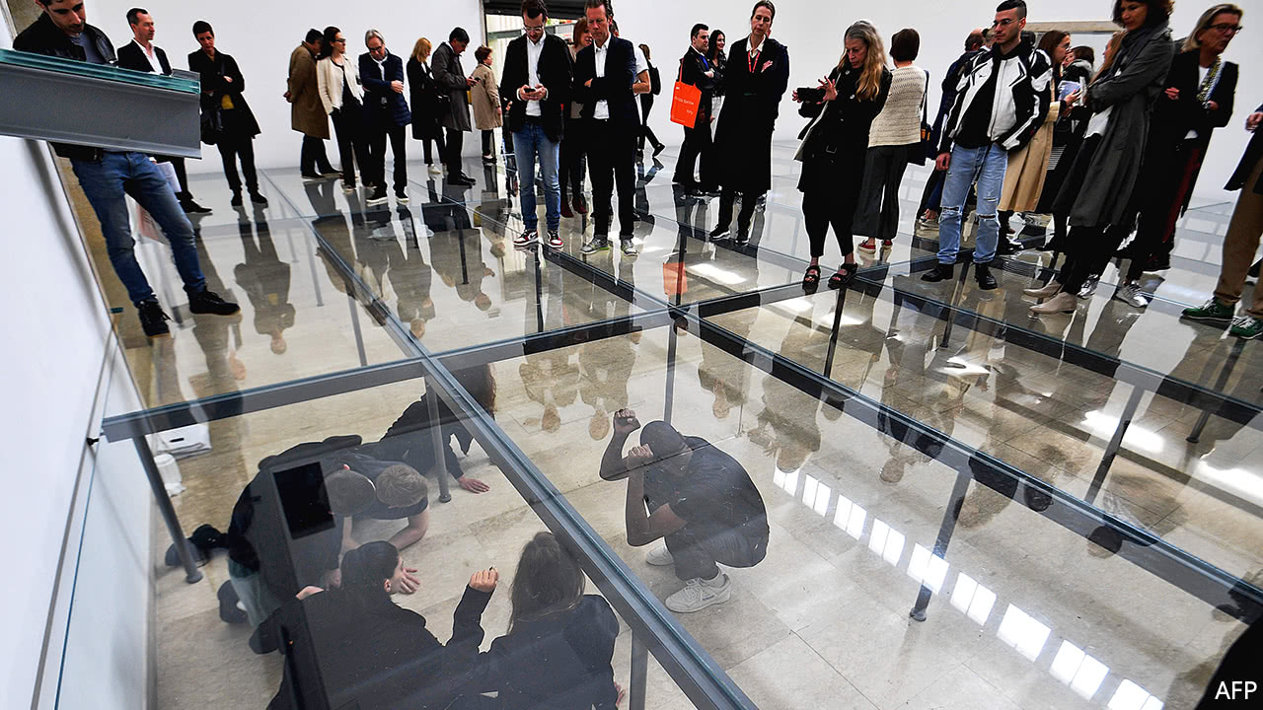
Art of the menace
The most successful pieces pack an emotional punch. In the German pavilion, which won the top prize for best national presentation, Anne Imhof has installed a slippery glass floor a few feet above ground level, which is lit a brilliant white (pictured). Visitors step gingerly across, looking down at bits of dirty cotton wool, phone cables, amplifiers, hospital sinks, broken eggs and unsettling brown stains. Then performers (young, black-clad and androgynous) begin to move under the floor. It is disturbing to feel you are walking over your fellow human beings while outside pairs of Dobermans are held in large metal cages. The meaning of the piece is elusive, but its menace is palpable and hard to forget.
In the American pavilion melancholy blackish-purple works by Mark Bradford, an African-American artist, refer obliquely to slavery and the migration crisis. Mr Bradford, an eloquent advocate, is also actively engaged in social projects in his native Los Angeles and in a women’s prison in Venice, but he says that this “is about working with people long term” and “listening and signing the cheques for what they want”, not about “co-opting people” into his own artistic practice.
In the Swiss pavilion a slow film shows an 81-year-old man telling the story of his mother, Flora Mayo, as a young artist. In the late 1920s she collaborated with the young Alberto Giacometti, who was also her lover. But she has barely been mentioned since except for a short, derogatory entry in James Lord’s admired (and admiring) biography of the Swiss artist which was published in 1985. The film’s underlying message is about how women are often written out of history; but what makes it powerful is that it is an elegy to time passing, to the sadness of wasted talent and the pain endured within families.
Meanwhile, in the South African pavilion, Candice Breitz filmed two Hollywood stars, Julianne Moore and Alec Baldwin, acting out real statements from refugees: a woman locked in a smuggler’s truck, a man fleeing charges of heresy, another terrified of being outed as gay. It is uncomfortable to hear the normally jocular Mr Baldwin saying with sincerity: “I really admire actors for the work you do,” and “Thank you, Alec, for taking part in this project.” Yet honest visitors admitted to be more fascinated by the highly emotive edited performances of the Hollywood stars than by the rather dull videos of the real refugees which are revealed in a second gallery.
By the time the Biennale closes in late November, more than 500,000 visitors will have made their way through it. Many can be expected to be just as liberal or international in their outlook as those who were invited for the preview week and treated as VIPs. The problem is that so many idealistic artists, even in this curated gathering, produce work that is simplistic and visually unexciting.
That may partly explain why some visitors still cleave to work that is glossy and glamorous, and fail to understand why more and more people find its moneyed character distasteful. The objects most commonly sewn on to Mr Medalla’s “A Stitch in Time” were business cards, not the meaningful embellishments the artist intended. Meanwhile, staff preparing a lavish party for François Pinault, an art collector, a major investor in luxury-goods firms, a backer of Mr Hirst’s show and the owner of Christie’s auction house, became anxious lest the 50 lemon trees brought in to decorate the venue looked less than fruitful. Orders were given for hundreds of plump extra lemons to be hand-tied to their branches. Despite the glasses raised to art and idealism at Venice, nothing illustrated the contrast between the rich and poor, the VIPs and the artists than the sight the next day of so many of those lemons, discarded and bobbing in the lagoon around San Giorgio Maggiore.

