Horse sense

The British government sells its last shares in Lloyds bank
But it still owns 71.3% of RBS, the other big bank rescued in 2008
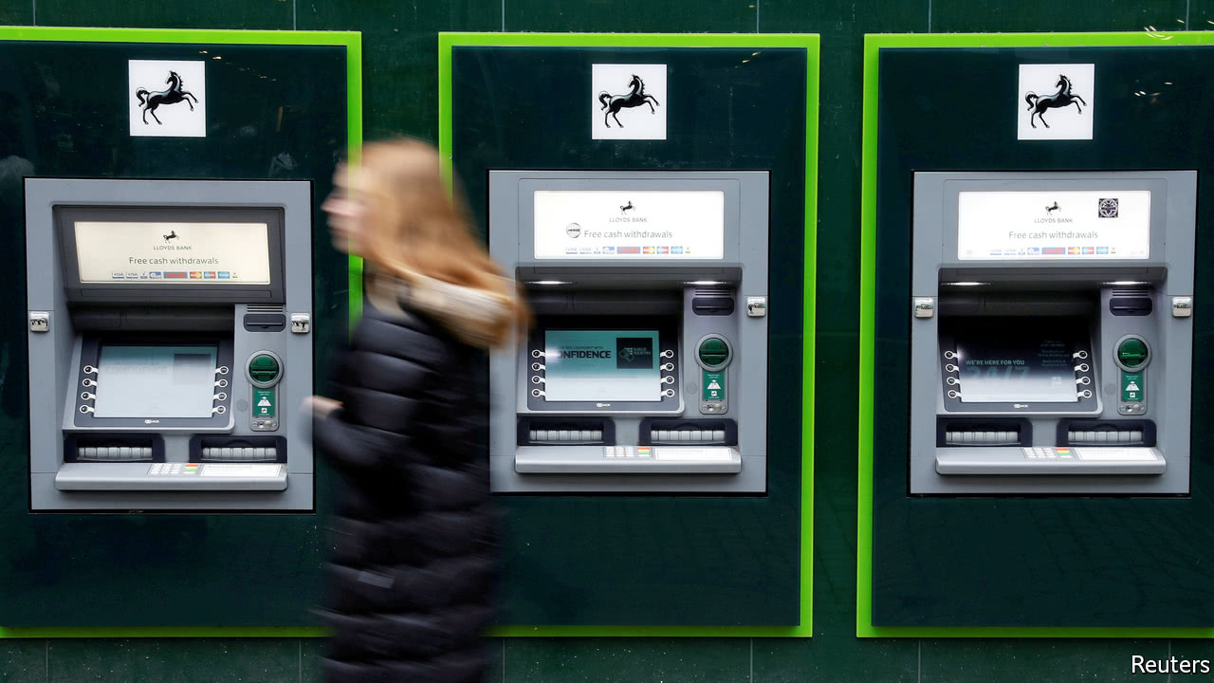

Print edition | Finance and economics
May 20th 2017

IN OCTOBER 2008, amid post-Lehman pandemonium, Britain’s Treasury said it would pump £37bn (then $64.4bn) into three big banks: £20bn into the stricken Royal Bank of Scotland (RBS); the rest into Lloyds TSB and HBOS, a sickly rival that ministers had cajoled Lloyds into buying. After rights issues in 2009, in all the state paid £20.3bn for 43.4% of the merged Lloyds Banking Group. On May 17th Lloyds said the last state shares had been sold.
The government has recouped £21.2bn, including £400m-plus in dividends, since it started to unload its stake in 2013. The return may sound slim, but had big lenders imploded the costs of the financial crisis would surely have been far greater even than they were. (Not surprisingly, anyone holding Lloyds TSB or HBOS shares since before the crisis has made a heavy loss.)
The group is Britain’s biggest retail bank. Its brands—Lloyds Bank, with its “black horse” logo, Halifax and Bank of Scotland—boast around one-fifth of both retail deposits and mortgages. Its share of small-business loans, where RBS leads the field, has climbed from 13% in 2010 to 19% last year. Under António Horta Osório, its chief executive since 2011, it has become slimmer and fitter. Some £200bn of bad loans, chiefly inherited from HBOS, have been run off. Wholesale funding, which in 2010 amounted to £298bn, 30% of liabilities, has been cut by nearly two-thirds.
Mr Horta Osório quit most foreign ventures—today 97% of Lloyds’ business is in Britain—and others including St James’s Place, a wealth manager. The European Union forced the sale of TSB, a brand acquired in the 1990s, as a condition of approving its state aid. It is not retreating everywhere: it expects the purchase of the British business of MBNA, a credit-card firm, from Bank of America to boost its share of that market from 15% to 26%.
To screw down costs Mr Horta Osório also stripped out three layers of management and placed budgets for travel, advertising and so forth under group-wide rather than divisional control. Like other banks, Lloyds is also closing branches. The workforce, 98,000-strong in 2011, will be down to around 70,000 this year (8,000 of the leavers went to TSB). Mortgage approvals and account opening have been made slicker. At 47.1%, the bank’s cost-income ratio is well below the European average.
The stain of past sin has not yet been washed away: Lloyds has set aside £17.4bn, more than any other British bank, to compensate customers for mis-selling payment-protection insurance (PPI) with loans. Separately, in February six people, including a manager at an HBOS branch in Reading, in southern England, were jailed for a £245m fraud, predating the takeover, that ruined several small businesses. Lloyds has provided £100m for compensation and commissioned external reviews of how much it should pay, and how the mess was handled.
These costs will fade: Lloyds hopes to make no more PPI provisions and regulators have set a deadline for complaints of August 2019. But they have weighed on earnings. Lloyds returned 8.8% on tangible equity in the first quarter. Stripped of provisions for bad behaviour and restructuring, the figure was a sparkling 15.1%.
Analysts like what they see. The bet on Britain has worked so far. Interest margins in the first quarter were wider than expected. Lloyds’ ratio of equity to risk-weighted assets, a key gauge of resilience, is a robust 14.3%, although the MBNA deal will dent this a little. If Lloyds meets its earnings targets and other plans, estimates Jason Napier of UBS, a bank, its dividend yield could be a healthy 8.2% this year.
Compare Lloyds with the other, bigger, bank rescued that tempestuous autumn. All told the state injected £45bn into RBS. After nine years of losses it still owns 71.3%, with scant prospect of getting its money back. Despite recent improvement—notably, a profit in the first quarter—RBS still has many woes. It faces fines in America for mis-selling mortgage-backed securities before the crisis. It is yet to meet its state-aid obligations, for which the EU is considering a new plan. And it is being sued by shareholders claiming to have been misled before a rights issue in 2008: next month Fred Goodwin, the boss who led RBS to disaster, is due to appear in court. Lloyds, alas, is less than half the story.

