Mr. Olympia Has 22-Inch Biceps and Eats 7 Meals a Day

WHEAT RIDGE, Colo. — It was a few minutes before midnight when Mr. Olympia, the top bodybuilder in the world, finished his workout at a nondescript gym in a tired strip mall. He lifted one of his 22-inch biceps and flipped the light switch, tapped the alarm panel and turned the key to lock the glass front door.
He hauled out a sturdy black trunk, the kind with shiny metal edges and a buckle for a latch, and opened the trunk to his white Mercedes.
“Mr. Olympia Phil Heath Parking Only,” the sign in front of the car read. “All others will be crushed.”
Heath bent his legs — each thigh about 32 inches around, bigger than his waist — and lifted the black case. Inside was his latest Mr. Olympia trophy. In bodybuilding, it is called the Sandow, and Heath has won the last six, most recently in Las Vegas in September. Arnold Schwarzenegger, still the world’s most famous bodybuilder, won six in a row, too, and then a seventh a few years later. Two men, Lee Haney and Ronnie Coleman, have won eight.
Heath is 36. He wants 10.
“Barring injury, I’ll smash it,” Heath said during a break in his workout a bit earlier. “I’ll get to 10. The question is: Can I continue to be a better version of myself?”
Heath wriggled the trophy case into his trunk. It barely fit. He shut the lid and drove the dark, empty streets toward home.
Heath is an unlikely Mr. Olympia. He grew up on playgrounds in Seattle playing basketball. His backcourt mate on the 1998 state championship team at Rainier Beach High School was Jamal Crawford, still in the N.B.A. Heath, just 5 feet 9 inches and a naturally chiseled 175 pounds, got a Division I basketball scholarship at the University of Denver. He majored in business and averaged 1.3 points over four seasons.
Heath looked for another athletic outlet when college ended. He found it in bodybuilding magazines and the university recreation center. Heath beefed up to a chiseled 200 pounds and soon began winning regional bodybuilding competitions.
He was genetically bequeathed with good bodybuilding genes: narrow joints and long attachments for proportion and big muscle bellies for bulge. That earned him a nickname, The Gift. By 2005, he was a professional bodybuilder. In 2008, he qualified for his first Mr. Olympia. In 2011, he won it. And every one since.

Photo
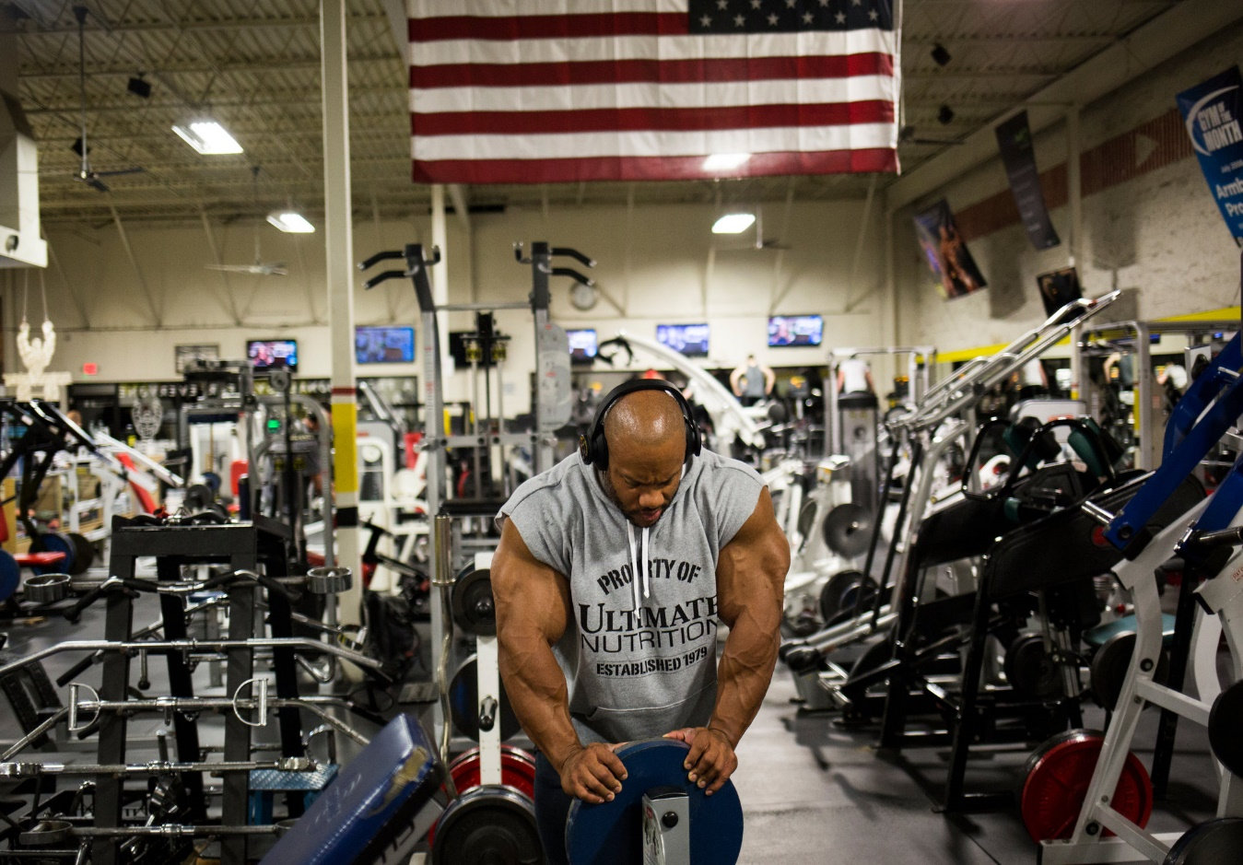
Phil Heath rested after a workout at Armbrust Pro Gym in Wheat Ridge, Colo. CreditNick Cote for The New York Times
Now Heath is a walking muscle chart, as if lifted from the wall of biology class. He competed at the last Mr. Olympia at 248 pounds, a symmetrical knot of bulges on top of bulges in places that most men never dreamed of bulging. The bundle is cinched at a 29-inch waist.
When he flexes he expands, like a rippled blowfish. The front of his thighs are something a balloon artist with too many balloons might create. His arms look like gnarled oak. His relatively narrow shoulders, once a drawback, are broad knots of deltoids and trapeziuses. His back is a relief map of impenetrable terrain.
“I produce a three-dimensional effect that others don’t have,” he said.
Armbrust Pro Gym, owned by a friend and open to Heath at all times, is filled with thick-limbed men and more weights than machines. Its grunginess gives it an authenticity that Heath likes.
A wall is decorated with photographs and magazine covers featuring Heath. He pointed to one and noted the striations within his biceps. “Detail on top of detail,” he said. He pointed to his quadriceps and noted the “different dimensions of crevices.”
Heath’s girlfriend, Shurie Cremona, scrolls her phone for a photograph of Heath on stage next to another competitor at Mr. Olympia. One man looks like the most muscular man in the world. The other is Heath, who is more — how to put it? — striated and creviced.
People sometimes walk up and touch him, as if unsure if he is a man or a machine. What they do not realize is that beneath the stony exterior and self-assuredness is a squishy sense of anxiety and vulnerability. Heath gets nervous every time he strips to his posing trunks. He is rarely satisfied with what he sees in the mirror. He is persistently worried about imperfections others might find, too.
But he often gets perfect scores at Mr. Olympia. His muscularity, combined with near-perfect symmetry, has made him unbeatable, for now, and maybe for several more years.
“It’s not just one body part,” said Robin Chang, vice president for events atAmerican Media, which co-owns Mr. Olympia with Weider Health and Fitness. “Some athletes have huge legs or a great pair of biceps. Phil beats you not with one pose, but with every single pose.”
Photo
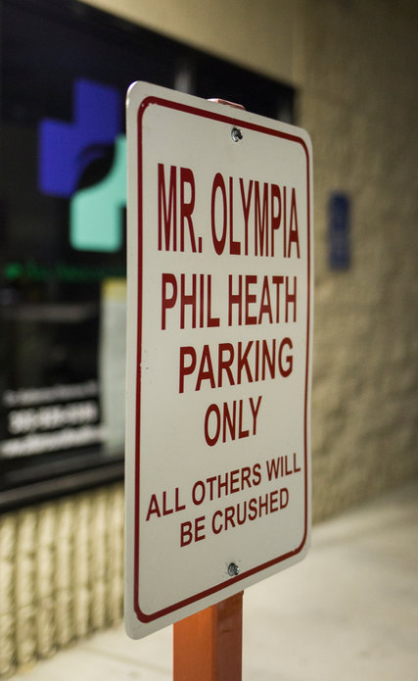
Heath’s parking spot at the gym comes with a warning that maybe shouldn’t be tested.CreditNick Cote for The New York Times
Heath has 1.8 million Instagram followers, 300,000 Twitter followers, a global fan base and a growing portfolio of muscle magazine covers. He competes in just one competition a year, Mr. Olympia, for which he won the $400,000 first prize this year. He spends the rest of the year staying in shape and flying hundreds of thousands of miles for appearances, conferences and meetings. He has five sponsors, led by Ultimate Nutrition, a supplement company. All told, he earns more than $1 million a year, his agent said.
He is talkative and quick-witted, quick to dispel the meathead stereotypes attached to bodybuilders. He likes to give motivational speeches. He has done two Middle East tours with the U.S.O.
Still, Heath is only occasionally recognized in his adopted hometown. The older and more successful he gets, the more ambition he has for something more — more titles, of course, but also a broader mainstream following. He wants a legacy beyond the record books of a niche sport.
It can be hard not to compare yourself to Schwarzenegger, with his action-star movie career, his stint as a president-appointed fitness ambassador and his election as governor of California. Chang said that Heath’s personality, including his charisma and outspokenness, is similar to that of Schwarzenegger, who is still omnipresent and beloved in the sport.
“Some say he’s a little egotistic, but he’s not,” Chang said of Heath. “He just knows what he has done. He knows he’s got the physique to back up his claims. Love him or hate him, you can’t stop talking about him.”
Heath has keys to Armbrust and half an office in the back. On a recent night, Heath; his girlfriend, Cremona; and his agent, Mark Bryant, squeezed into the room, the floor cluttered with file cabinets, suitcases and cardboard boxes spilling T-shirts and banners.
A wall had a poster of Schwarzenegger next to a framed, blown-up Flex cover of Heath. From the gym on the other side of the wall came heavy metal music and the occasional percussion of heavy metal weights crashing to the floor.
Heath wore a sleeveless hoodie. Finding clothes is difficult. To accommodate his thighs, he mostly wears size 3XL Lululemon pants with a drawstring pulled tight at his narrow waist. He wears custom-made T-shirts, size 4XL, with the sides tapered.
Photo
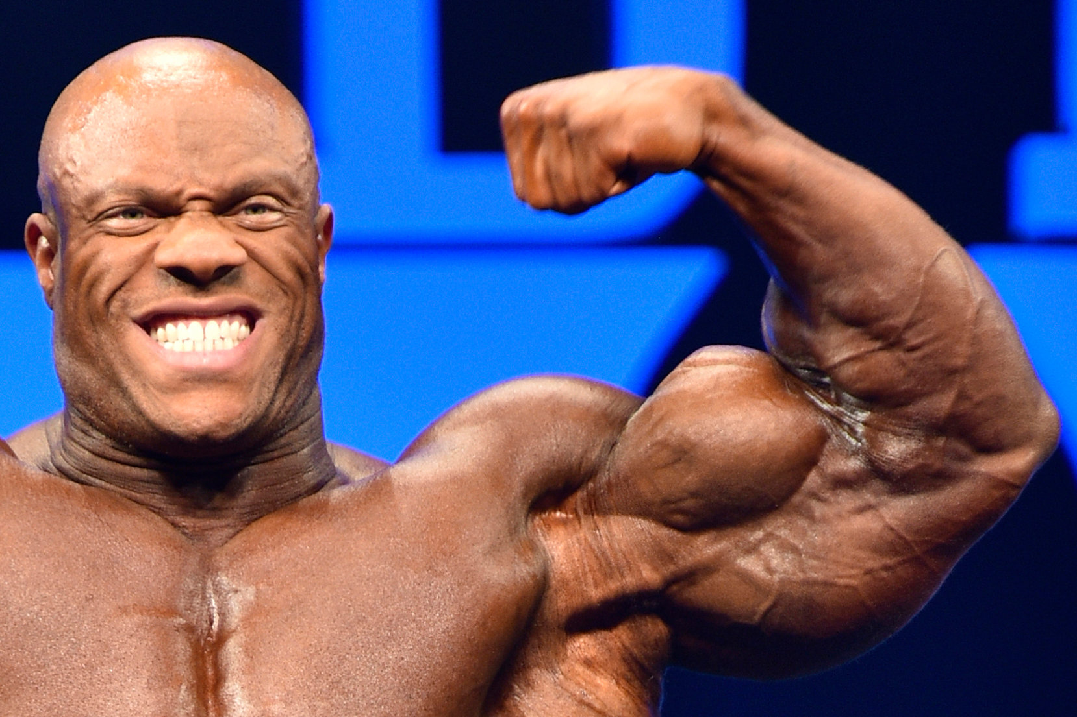
Heath’s muscularity and symmetry have made him unbeatable for now, and maybe for several more years.CreditIgor Kopcek/EastLabs.SK
The hardest part of winning every year, he said, is having to defend it after a year of appearances and global travel. Discombobulated schedules, foreign foods, inconsistent gyms, cramped airplane seats and uncomfortable hotel beds are among the inconveniences that can alter his body, inside and out.
He eats six or seven meals a day. He is divorced, but he has found in Cremona someone who will do his food shopping and meal preparation, on top of being a travel partner and business adviser. She spends $1,000 or more a week on his food, mostly at Whole Foods, and spends roughly six hours a day in the kitchen.
Daily, Heath usually eats five to six pounds of protein-rich meats — filet mignon, chicken, turkey, salmon and tilapia, mostly. He consumes up to 75 grams of carbohydrates in the form of grits or oatmeal, white or brown rice, and various types of potatoes, including sweet potatoes. Mornings might bring 16 ounces of scrambled egg whites. He tries to drink two gallons of water a day. His off-season weight usually reaches 275 pounds or more, still chiseled.
“The issue is how does my body assimilate to various proteins, carbs and fats?” Heath said.
A big clue is digestion. He does occasional cleanses. (“There’s no planes that week,” he said. “And no judgment at home.”) The slightest change in a muscle, just a stripe in a striation, is noticed. And while Heath does most workouts alone, he has a trainer, Hany Rambod, who is based in California. They see each other about once a month. In between, Heath sends photos and receives workout and dietary advice in return.
As Heath talked in the office, Cremona presented him with steak and white rice. It was takeout, from Outback Steakhouse, because the two had just returned from a weeklong trip. Heath reached toward a bouquet of round plastic jars filled with powdered supplements. He scooped powder from one into a water bottle, shook it and drank. He compared himself to a racecar, always in need of fuel and delicate tinkering.
It raised the question about performance-enhancing drugs. Their murky role in bodybuilding has long shrouded the sport. A 2013 documentary on Heath and Mr. Olympia called “Generation Iron” (a sort of bookend piece to 1977’s “Pumping Iron,” which launched Schwarzenegger and others to fame) called the topic “taboo.” It then insinuated that, of course, bodybuilders competing in top-level contests like Mr. Olympia use steroids.
“Everybody is going to do what they do,” Heath said, the only time over many hours that he was curt and declined to elaborate. “But we get tested.”
Photo
Heath ate in his office at the gym before a workout. He eats six or seven meals a day, consuming five to six pounds of rich proteins, like filet mignon, chicken, turkey, salmon and tilapia. CreditNick Cote for The New York Times
Mr. Olympia is part of the International Federation of Bodybuilding Professional League. The I.F.B.B. says that it operates under the guidelines of the World Anti-Doping Agency and that competitors are subject to drug testing. Chang, who oversees the Mr. Olympia contest, said that I.F.B.B. testing is random, but is not conducted during the Mr. Olympia contest itself.
Fans of Mr. Olympia do not seem caught up in the issue, perhaps because the sport is entirely about aesthetics, not strength or performance.
Heath moved into the gym to work on his arms. Headphones on, he was given plenty of space by the 10 or so people in the gym late on a weeknight.
“I keep to myself, but I watch people,” he said. “You don’t know what that person on the treadmill is going through.”
He spent an hour doing various curls, sometimes with barbells that looked small in his hands.
“It’s not about the weight, it’s about the movement,” he said.
He looked at himself carefully in the mirror between sets. Sometimes, Cremona takes pictures of him from behind and underneath so that he can work on body parts that he cannot see.
Heath has no gym at home, which means regular 30-minute trips to Armbrust, sometimes in the middle of the night. The police have been known to come to the glass doors shining flashlights inside, wondering who is inside the gym at 3 a.m.
“He’ll call me at midnight and say he’s on the way to the gym,” Bryant said. “And I’m like, ‘Didn’t you already work out today?’ And he says, ‘Yeah, but I didn’t like the way it went.’ ”
Each day is set aside for different body parts — the back on Monday, the chest on Tuesday, the legs on Thursday and so on. After a celebratory vacation in Mexico with Cremona, Heath looked at the videos from Mr. Olympia.
“I look good, but I can see places I can improve,” he said.

